Meta Title:
Shop Exclusive Pre-Owned Vacheron Constantin Watches
Meta Description:
Shop authentic pre-owned Vacheron Constantin watches at Swiss Ice Co. Visit our San Francisco or Los Angeles stores for unbeatable deals and quality assurance.
Watches Vacheron Constantin | https://swissiceco.com/collections/watches-vacheron-constantin | vacheron constantin watch  Pre Owned vacheron constantin watch  vacheron constantin watch price  vacheron constantin watch for sale
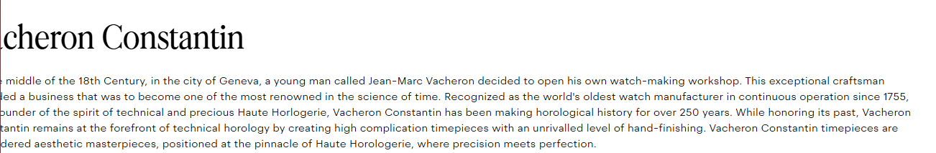

Vacheron Constantin Watch

Looking for Vacheron Constantin Watches for Sale? Welcome to Swiss Ice Co, a company that specializes in selling high-end luxury Vacheron Constantin watches. Our Vacheron Constantin surely provides you with more attention and gives you a feeling of style. The devotion to the idea that our clients deserve the best can be seen in the selection of Vintage & Contemporary Vacheron Constantin timepieces that embody the rich tradition and craftsmanship of the brand admired all over the world.

The Heritage of Great Elegance:
Vacheron Constantin has been regarded as the connoisseur of elegance reflection and the world’s foremost luxury watchmaker since the year 1755. This brand has earned its reputation for the production of fine timepieces, and a timeline of its existence is studded with breakthroughs and brilliance of horology enthusiasts. At Swiss Ice Co, we continue this rich heritage by offering high-quality new and pre owned Vacheron Constantin watches that represent the brand at its best and prove our company’s long-term dedication to quality. if you are a collector and want to buy certified and authentic Vacheron Constantin, then you won’t be disappointed. We have a wide variety of timepieces in a luxurious realm of carefully curated selection, all at affordable prices.

Exclusive Timekeeping Admired by Everyone:
Vacheron Constantin watches for sale in Swiss Ice Co are certified and come from brands that have steered the course of the Swiss watch-making business in the country. Every model that we offer has been created by highly skilled professionals known as watchmakers and contains a unique blend of engravings, exceptional movements, and detail. Starting from dress watches, going through simple time only to more complex and sporty chronograph models, the inventory is huge, and by offering all kinds of models, it is easier for you to find the best Vacheron Constantin watch for sale, which will better resonate with your personality and demands.

Observe Superior Quality Like None Other:

Swiss Ice Co appreciates the fact that time is valuable and for this reason, our team of professional horologists scrutinize all the pre-owned Vacheron Constantin watches as we prepare them for the market. This means that when you purchase your timepiece from us, you can be sure that the item arriving at your door will be in perfect condition. Our watches are in working condition and we will make sure that you get a stylish, elegant, and accurately telling time Vacheron Constantin watch.

Experience Authenticity Luxury:
At Swiss Ice Co, we prioritize the quality of our pre-owned Vacheron Constantin watches. Our team members carefully check the history of every genuine watch through the identification of its specific characteristics, movement, case, and dial, as well as official certificates and documents. Such stringent authentication means that the wearer gets the original Vacheron Constantin watch which enhances the worth of the watch that the buyer is acquiring.

Luxury Within Reach: Affordable Watches
Watches of Swiss companies are elegant and classy and are usually very expensive. However, at Swiss Ice Co, we consider price tenders a crucial factor when making our collection. This is why we brought into the market our elegant certified pre-owned Vacheron Constantin Watch price at nominal rates so that you can afford that luxury. Our staff dedication is to ensure that our customers receive the highest satisfaction for their money. That is why Swiss Ice Co has become a haven for the most elite watch connoisseurs in search of Vacheron Constantin for sale.

Discover The Oz of Watchmaking With Swiss Ice Co:

At Swiss Ice Co, we make our customer’s shopping experience as enjoyable as possible and ensure we assist them in choosing the best Vacheron Constantin watch of their desire. Our employees are very experienced in the field of luxury watches and fully ready to help you choose the perfect watch that will match your personal preferences.

Missing out on owning a pristine pre-owned Vacheron Constantin watch from Swiss Ice Co. Well, you can now visit us today to explore our collection of outstanding timepieces that will impress anyone who values Swiss-made luxury watches. Do not hesitate to shop for the best experience only at Swiss Ice Co.

